

**CSE302 (Section 1)**

**[Summer 2022]**

**Lab Assignment Submission Report**

**Assignment Title: Lab 1**

**Submitted by:**

**MD. ASIF HASAN**

**2020-1-60-079**

**Screenshots**

**Problem 1:**

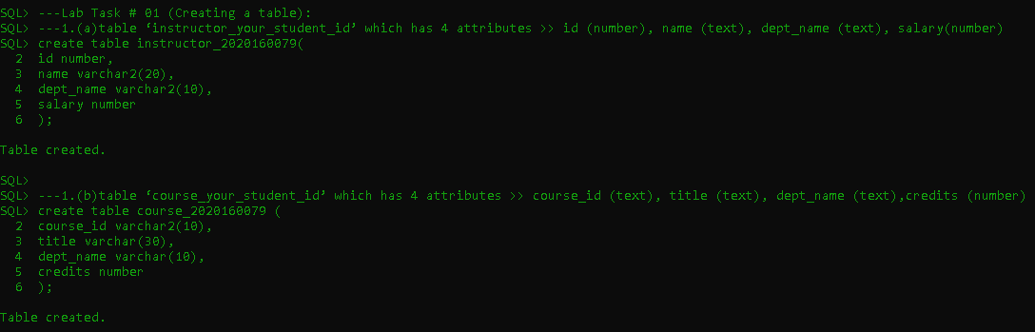

**Problem 2(a):** 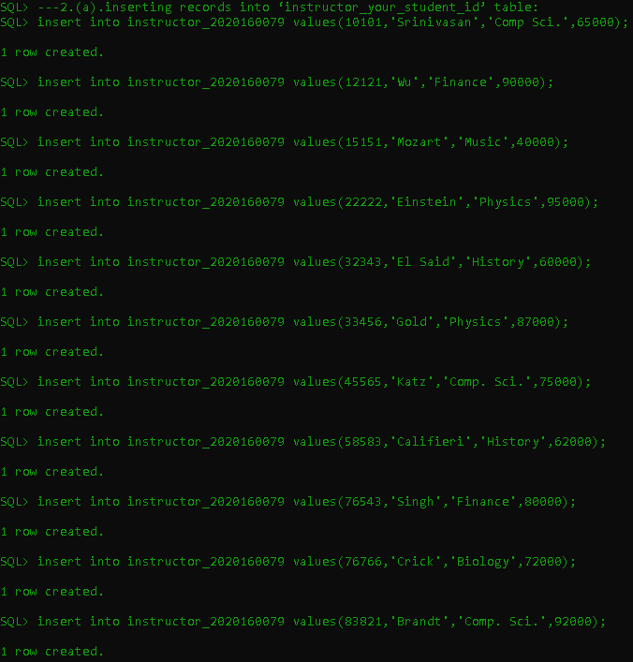

**Problem 2(b):**

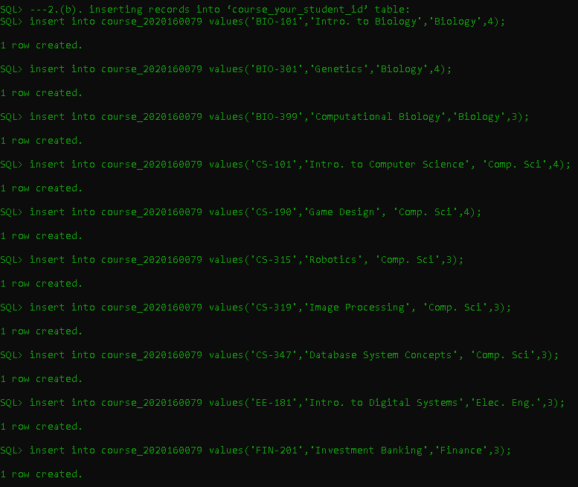

**Problem 3**

**i. 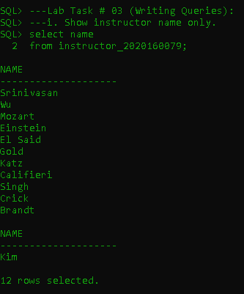ii.** 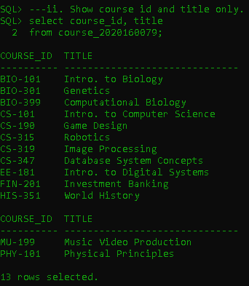

**(iii – v).** 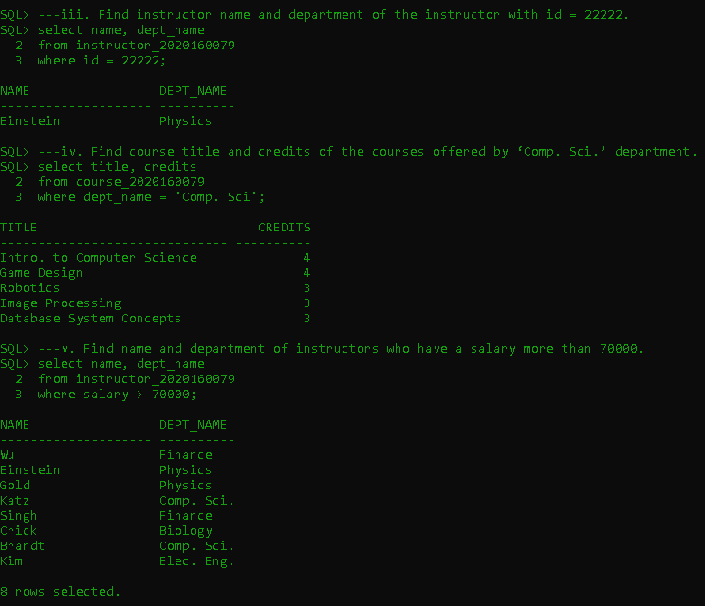

**(vi-vii).**

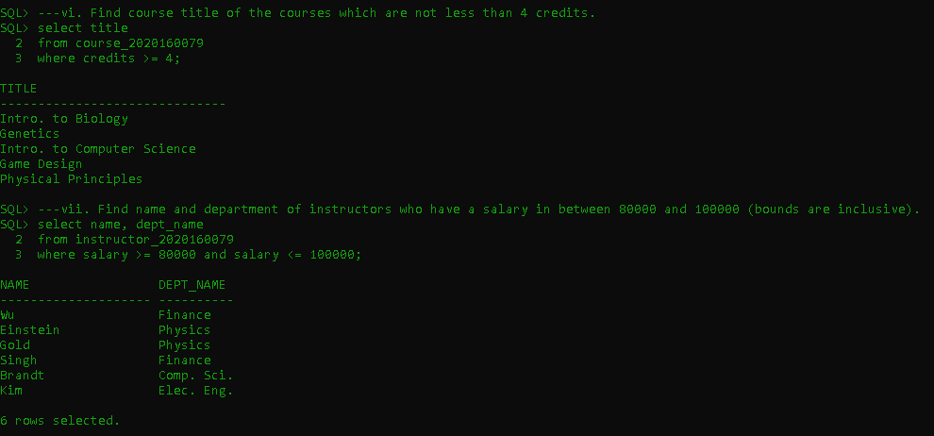

**(viii-ix).** 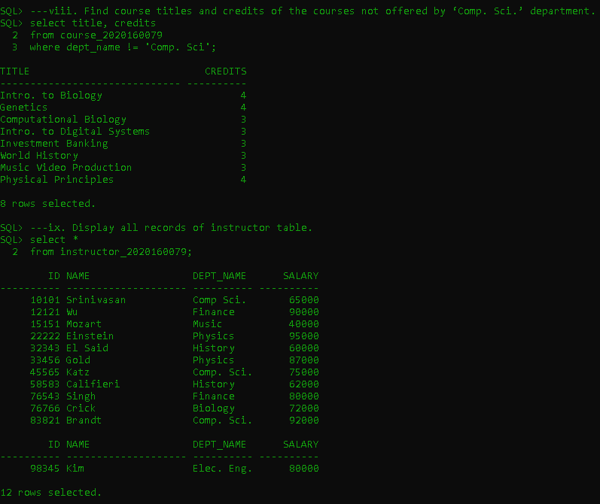

**X.**

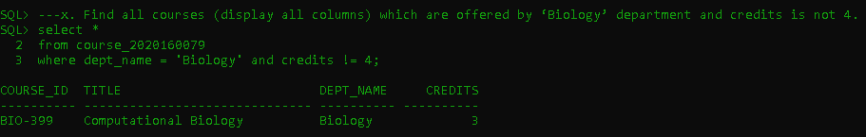

Learning Outcomes

1. **Create a table**
2. **Add data to them**
3. **Read and get specific data from the table with query.**